TITLE
Author 1a, Author 2b, Author 3c and Author 4d
a Author 1’s affiliation, Address,
b Author 2’s affiliation
c Author 3’s affiliation
d Author 4’s affiliation
Corresponding author’s e-mail address: aaaaaa@bbb.cc
Keywords: Keyword1, Keyword2, Keyword3, Keyword4, Keyword5 (Limit 5 Keywords)

ABSTRACT
Abstract (200-300 words including the information of background, objective, method, main findings and results.) The manuscript should be limited to one page, and you may include up to one figure.

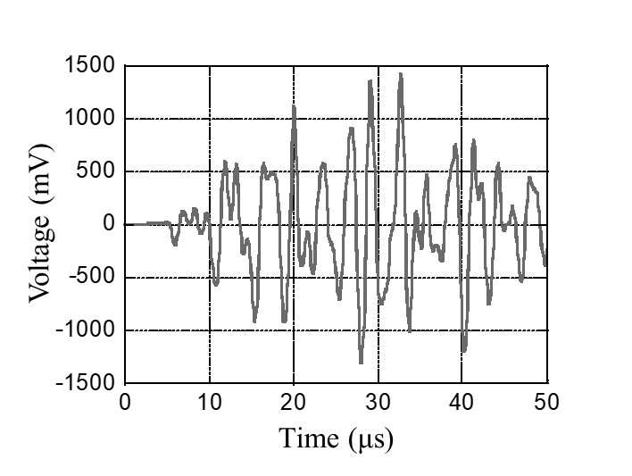
Fig. 1 Elastic wave.

